<https://circuitdigest.com/electronic-circuits/diy-xl4015-dc-dc-buck-converter-module>

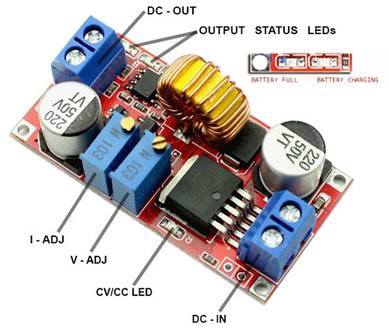

Data sheet: <https://pdf1.alldatasheet.com/datasheet-pdf/view/763183/ETC2/XL4015.html>

Schéma:

Seznam součástek:

* XL4015 Buck Converter IC – 1
  + <https://www.tme.eu/cz/details/lm2596s-adj_nopb/stabilizator-napeti-obvody-dc-dc/texas-instruments/?brutto=1&currency=CZK&gclid=CjwKCAjwvfmoBhAwEiwAG2tqzNWIArj24DRkX3sH5BhdPXsVl7sLIV8Sa-_j50DIUVW4a_PY0To31xoCDesQAvD_BwE>
* 78L05 Voltage Regulator – 1
  + <https://www.tme.eu/cz/details/l78l05abd13tr/stabilizatory-napeti-neregulovane/stmicroelectronics/>
* LM358 op-amp – 1
  + <https://www.tme.eu/cz/details/lm358am_nopb/operacni-zesilovace-smd/texas-instruments/>
* SS54 Schottky Diode- 1
  + <https://www.tme.eu/cz/details/ss54bf-dc/diody-schottky-smd/dc-components/ss54bf/>
* TL431 Programmable Reference – 1
  + <https://www.tme.eu/cz/details/tl431acdbzr/zdroje-napetove-reference-obvody/texas-instruments/>
* 470uF,35V Capacitor – 2
  + <https://www.tme.eu/cz/details/aea1213471m035r/elektrolyticke-kondenzatory-smd/kyocera-avx/>
* 10uF 0805 Capacitor -2
  + <https://www.tme.eu/cz/details/08053d106kat2a/kondenzatory-mlcc-smd/kyocera-avx/>
* 10K Ten Turns Trim Pot – 2
  + <https://www.tme.eu/cz/details/t93ya10k/potenciometry-viceotackove-tht-3-8-palce/vishay/t93ya103kt20/>
* 0.1uF Capacitor – 3
  + <https://www.tme.eu/cz/details/cl21b104kbcwpnc/kondenzatory-mlcc-smd/samsung/>
* 270R Resistor – 1
  + <https://www.tme.eu/cz/details/ar0805-270r-0.1%25/rezistory-smd/viking/ar05btcw2700/>
* 1K Resistor – 2
  + <https://www.tme.eu/cz/details/ar0805-1k-0.1%25/rezistory-smd/viking/ar05btcw1001/>
* 2.2K Resistor – 1
  + <https://www.tme.eu/cz/details/erjp06f2201v/rezistory-smd/panasonic/>
* 10K Resistor -  1
  + <https://www.tme.eu/cz/details/ar0805-10k-0.1%25/rezistory-smd/viking/ar05btcw1002/>
* 71.5K Resistor – 1
  + <https://www.tme.eu/cz/details/ar0805-71k5-0.1%25/rezistory-smd/viking/ar05btcw7152/>
* 90.9K Resistor – 1
  + <https://www.tme.eu/cz/details/ar0805-90k9-0.1%25/rezistory-smd/viking/ar05btcw9092/>
* LED 0805 - 3
* Screw Terminal - 2